**Android Lab – Introduction to Activities and Events**

**App 1: TSA**

Make sure you have the TSA Line Randomizer app working correctly.

* What's the name of Android's build tool?
* Add some screenshots of your app running.

**App 2: LMGTFY**

Make sure you get the LMGTFY app running.

* Add some screenshots of your app running

**App 3: Map Intent**

Make sure that you have the Map Intent app running correctly. Test it with some example locations. Also check that you see the Toast if you enter a location that can't be resolved into an address.

* Add some screenshots of your app running.
* Add some screenshots of your log messages in LogCat

**App 4: Who Goes First?**

Create an app that randomly selects one of two teams to go first in a game or match.

For example, if your app is given the names of two soccer teams, randomly select one of the two teams to kick off first.

Create a new app, using the default configuration.

Open activity_main.xml.

* Create two EditText widgets, one to enter each team name.
* Create two TextView widgets, one to label the first EditText "Team 1" and the second "Team 2"
* Add a Button with the text "Select Random Team"
* Add another TextView with the text "Result shown here".

An example layout is shown below, or you can arrange components in your own design.

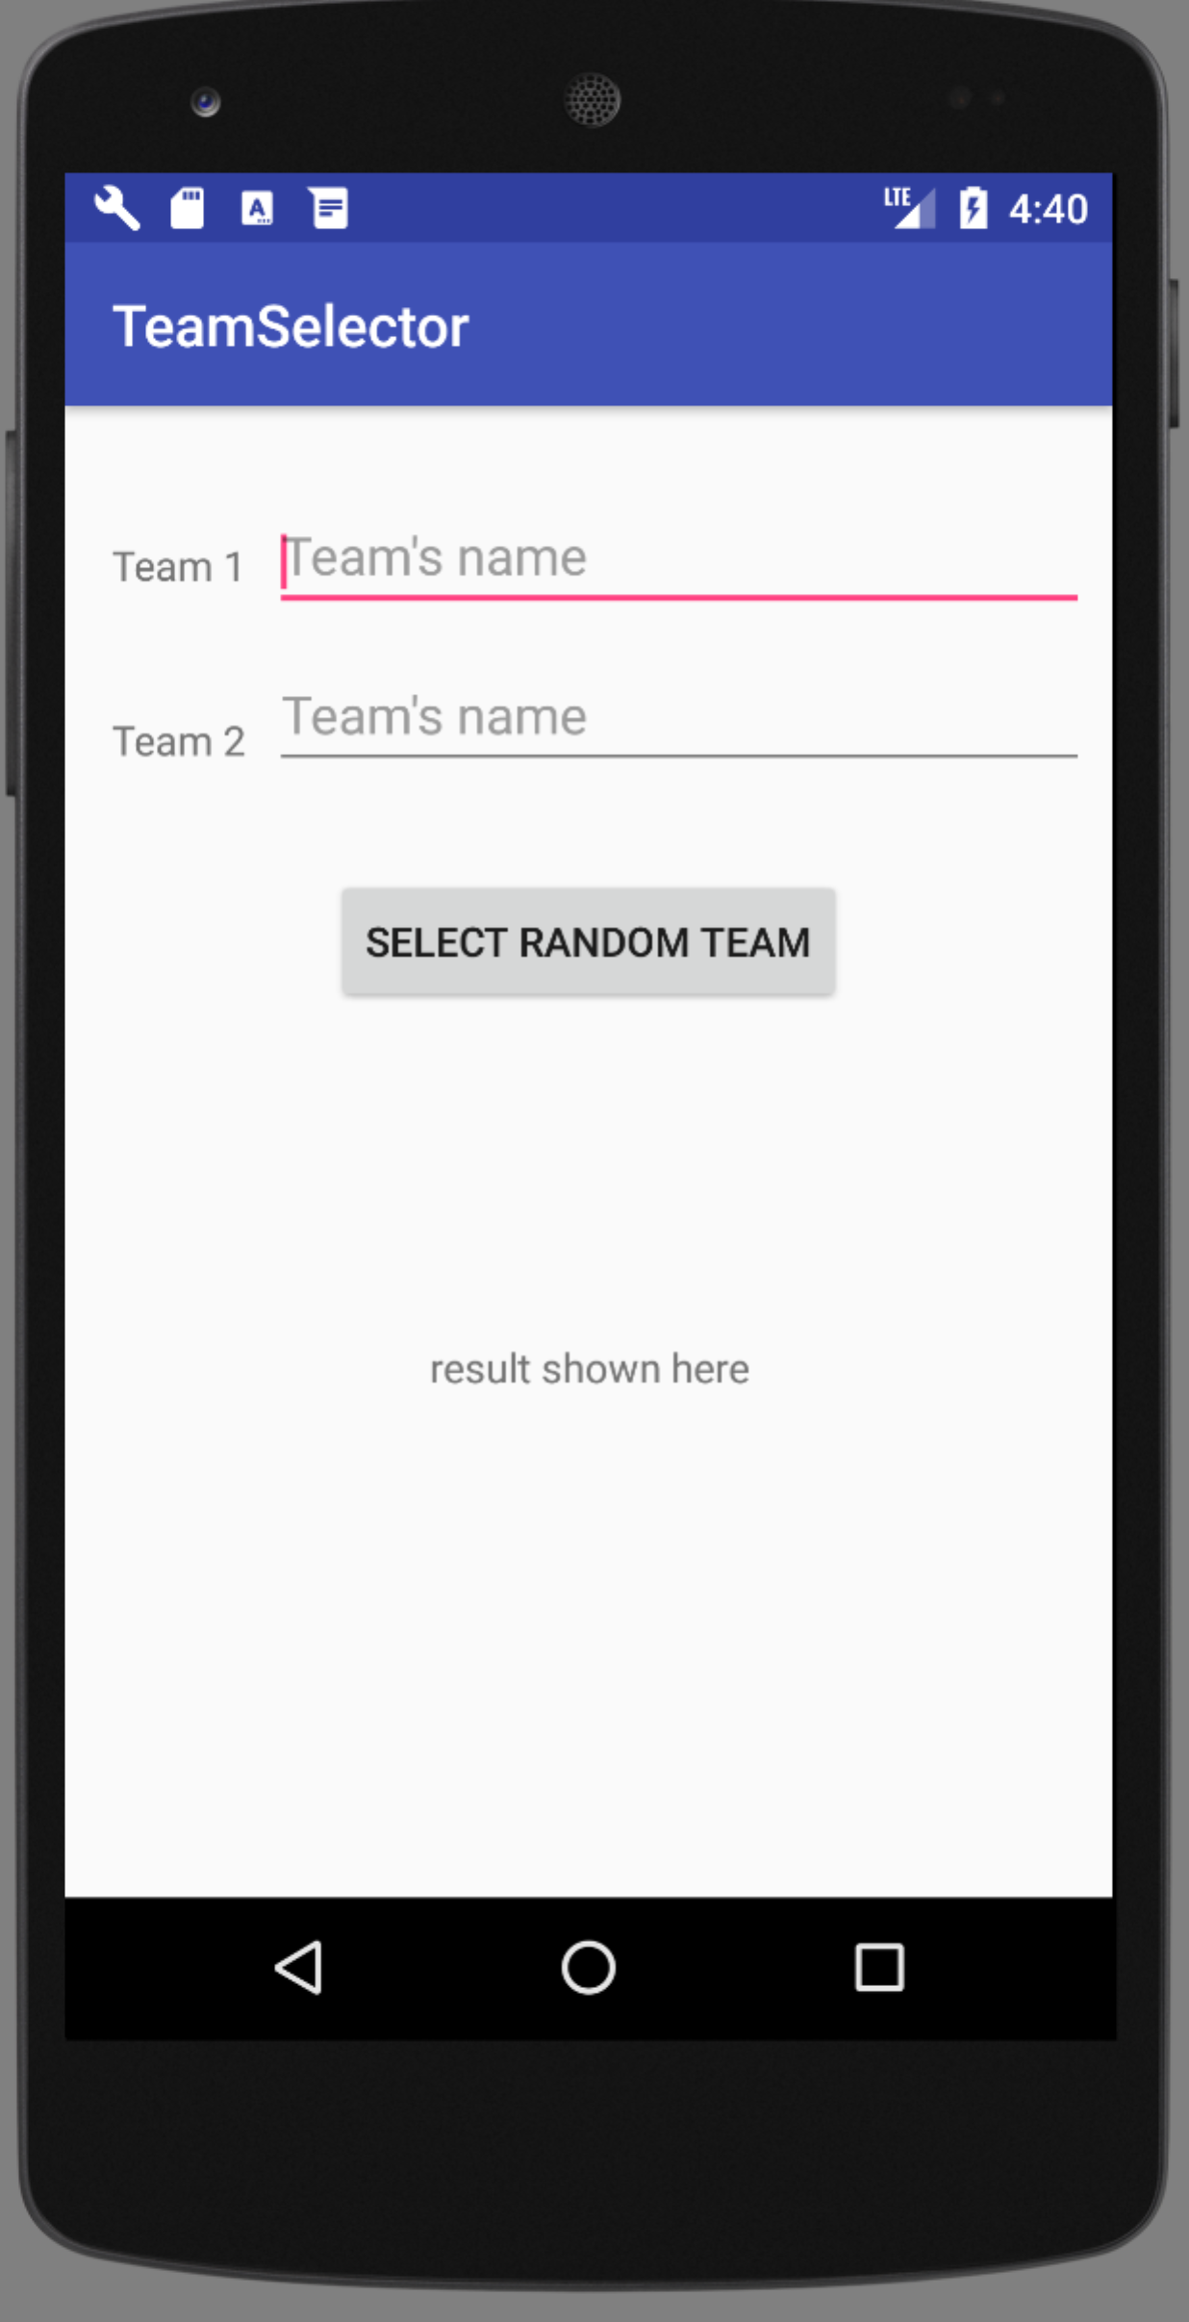

Next, open MainActivity.kt. Add code to

* Add a click event listener to the Select Random Team button
* When the button is clicked, read both the team names from the EditText widgets
* Check that the user has typed something into both EditText widgets
  + If they haven't, use a Toast to remind them to fill in both EditText widgets
  + If they have entered two names, randomly select one of the two team names, and display it in the result TextView

Run and test your app.

Write comments in your code.

* Add some screenshots of your app running
* Create a Git repository and push all your app code to GitHub and paste the link here.

**App 5: Big Nerd Ranch GeoQuiz App: Chapter 1 and 2**

Read, and follow the steps in Chapter 1 and Chapter 2 of the textbook to start building the GeoQuiz app.

Run and test your app, and make sure it is working as expected.

Please comment your code!

* Add some screenshots of your app running
* Create a Git repository and push all your app code to GitHub and paste the link here.

**Optional Challenges**

**Note** on the optional challenge at the end of Chapter 1, setting the position of the Toast – setting the gravity/position of a Toast no longer works as of Android R, so skip this challenge.